‏‏‏‏‏
Digital Water Flow Meter

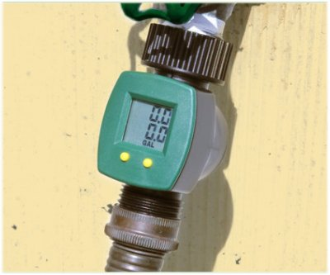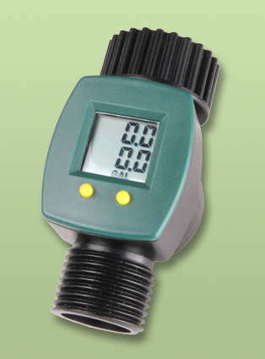

Specification

Counters | 2
Measurment | 0…999.9
Units | Liter or Gallon
Accuracy | +-5%
Thread | 3/4" - European threading
Pressure | 0.5- 8 Bar

Manual

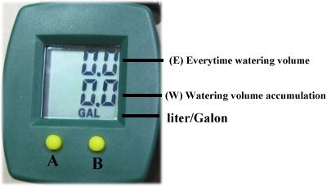
The water meter has 2 counters:
Counter- E - session reading (upper value)
Counter-W - accumulate reading (lower value)

Battery save mode:
Your Digital Water Flow Meter comes to you with battery already installed and it will measure up to 999.9 liters.
The screen will fade out in 30 minutes if there is no water flow or no button activation.
The Accumulated value (B) will remain in the memory

Working
1) Press shortly button A or B to wakeup the LCD
2) The device will detect any water flow and start to count.
3) When water flow commences, both counters (E) and (W) will count the flow volume
4) To reset Counter-E (session reading) press button A shortly
Counter-W continue to accumulate water volume
6) To reset Counter-W, press button B for 3 seconds

How to switch units (Liter/Gallon)
- Press button A for 3 seconds and release. A dark point on left will flash.
- Select GAL or LIT by pressing button B
- Press button A to confirm setting

